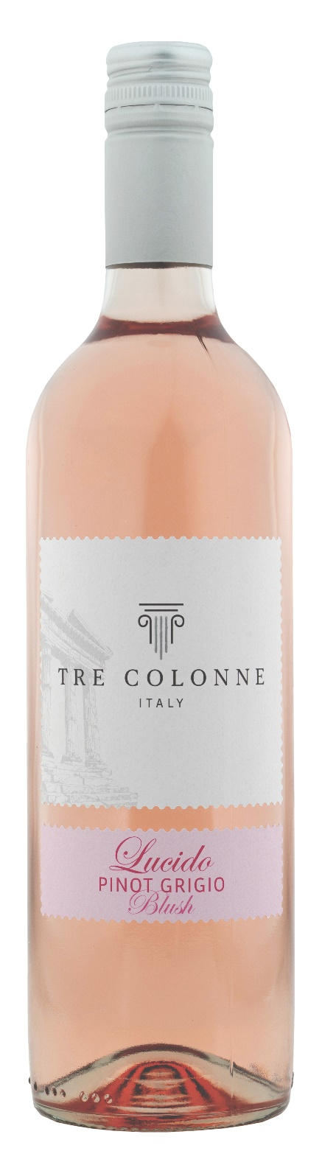
LUCIDO PINOT GRIGIO ROSATO IGP – TRE COLONNE

Grape: Lucido 80%, Pinot Grigio 20%
Alc. Vol.%: 12
Vintage: 2025
Residual sugar g/l: 5,0
Total acidity g/l: 5,6
Region: Sicily
Production zone: Vineyards in western Sicily
Capacity: 750ml

CHARACTERISTICS

Vinification: Maceration of the must with the berry skins at 0°, then separation and fermentation at a controlled temperature
Aging: In steel tanks until bottling
Yield per ha: 14000kg
Colour: Light pale pink
Bouquet: Delicate, round and fruity
Flavour: Smooth and pleasantly refreshing

SERVING SUGGESTIONS

Excellent as an aperitif, with fish dishes and light starters.
Serving temperature 6-8 °C
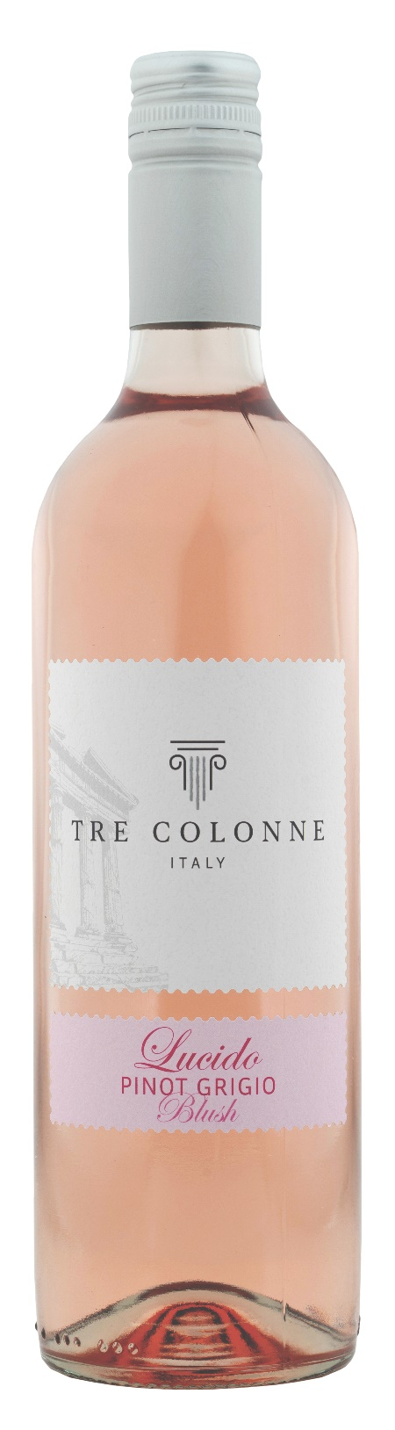
TECHNICAL INFORMATION / PALLETIZING

Size 750ml:
Article Nr. V14013A
GTIN-13 bottle 8017868005124
GTIN-13 carton 8017868005605
Closure Cork/Screwcap
Bottles / carton 6 bottles
Pallet size 80x120cm
Cartons/layer 25
Cartons/pallet 125
Kg/carton 7,0
Kg/pallet 892

Contains sulphites
GMO Free
Revisione 01. 14.05.2026

